Hey Joel,

I really enjoyed your website, the color scheme is very clean and matches nicely with the fonts. The pages are consistent and have some great content on them. I love the photograph style you gave the image on the about page. At first I thought it was just an image, but it's really cool that it's more like a realistic photo with shadow. One thing that I suggest is that you figure out how to get the footer to go to the bottom of the page, its a tricky thing sometimes, but there are many guides on it, and on that thought I think you should remove any padding/margin that you add to the body/html tag. Personally it gives off a weird feeling that there is so much white space on the sides and top/bottom.

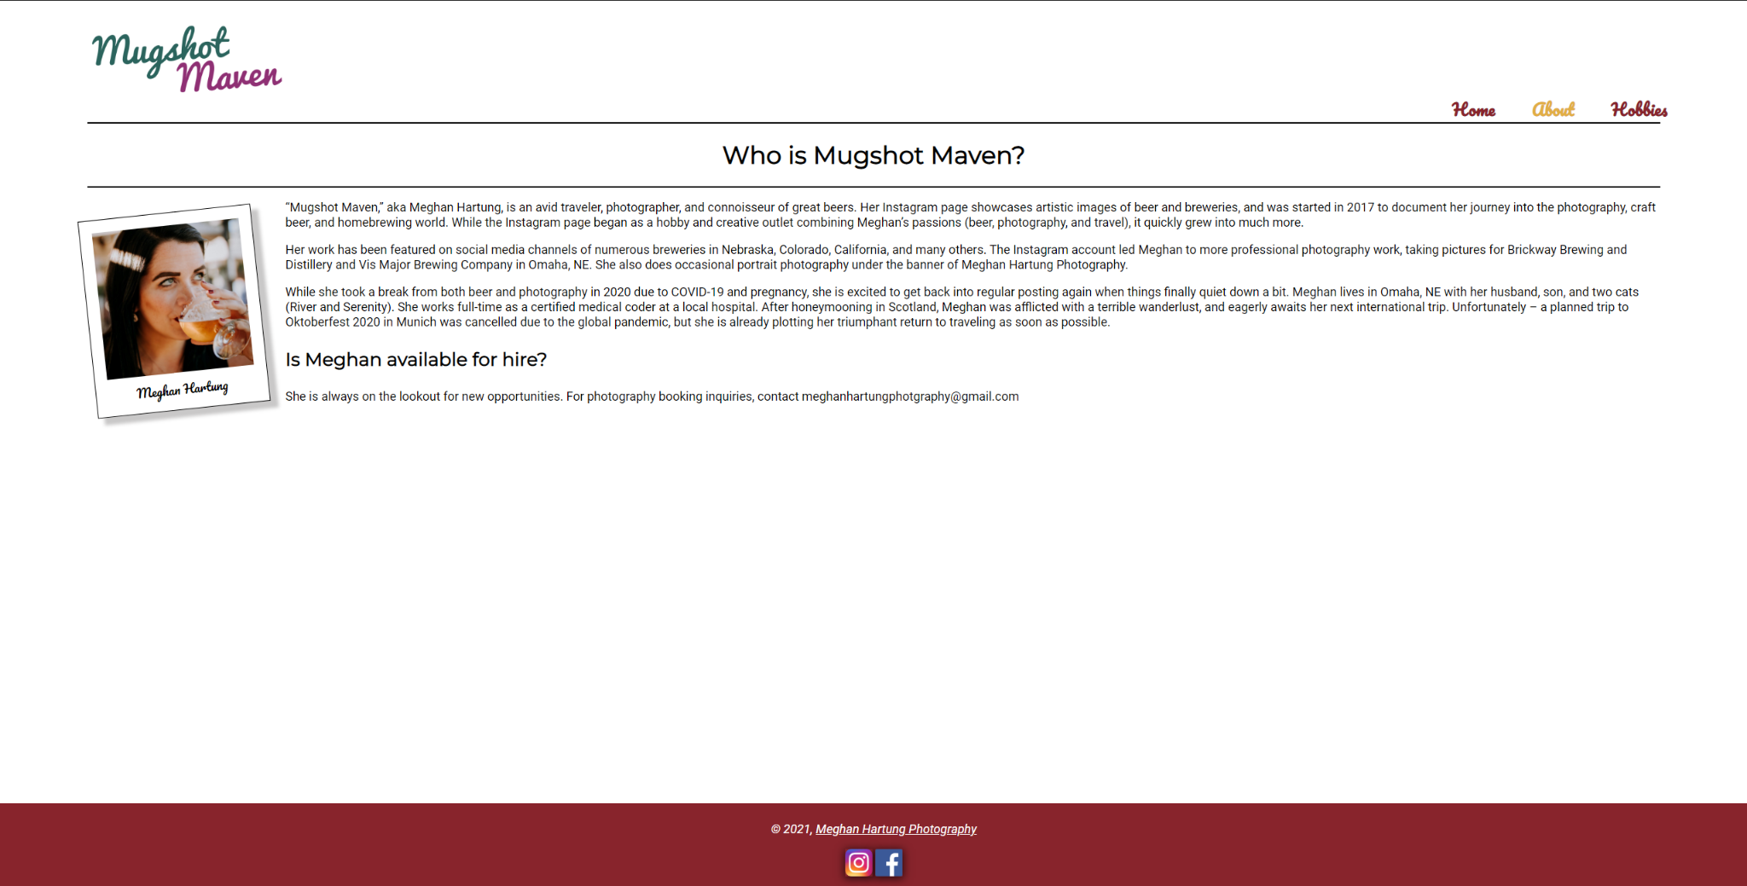

Here i removed the padding/margin from the html/body tags

And adjusted the footer to align on the bottom.

On your footer tag:

Position: absolute;

Bottom: 0;

Removed margin

On html tag:

Removed margin

On body tag:

Margin: 0;

Padding: 0;

One last suggestion on your hobbies page

On the .home-content-image class:

Added margin-bottom:30px

.image-caption class:

Removed bottom

Removed position

This allows your captions to have more space making it easier to read.

